Useful Commands and Tips

# Flutter Commands –

* flutter upgrade – to update flutter installation files
* flutter devices – to see list of available flutter devices
* flutter emulators – to see list of available flutter emulators
* flutter doctor – to check if there are any problems with flutter installation

# Flutter Commands to be run inside project directory –

* flutter emulators --launch <emulator name> - to run flutter emulator, you can get emulator name from flutter emulators
* flutter run – to run current project on emulator

# Git Hub Commands –

* Clone – to clone repository to local disk
* Fetch Origin – to fetch any changes to repository from origin
* Pull – to change repository to the one fetched from origin
* Commit – to commit changes to the repository
* Push – to push committed changes to the origin

# Tips

* Use Google collab for data analysis
* Open VS Code directly after cloning repository from GitHub Desktop.
* Make sure you are inside the project repository before executing any commands.
* 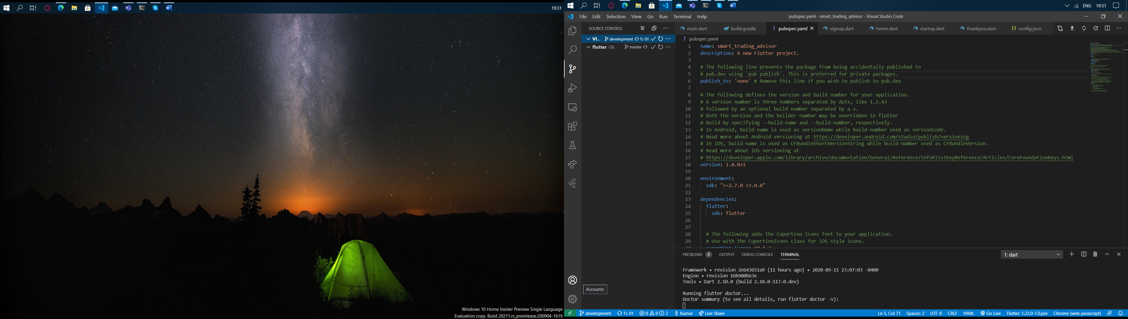 You can sign into GitHub from the bottom left of your VS Code to use GitHub from VS Code directly.
* You can then control GitHub by pressing Ctrl+Shift+G.

# Do’s

* Run ‘flutter channel master’ and ‘flutter upgrade’ to get the newest version of flutter
* Save *pubsec.yaml* file on loading new project.

# Don’ts

* Do not run the app while there is still an error showing in any of the dart files.
* Do not commit any changes in the master branch of the GitHub repository.